Energy Saving Automated Stairway Lights

Jinnyrose Genotivo Olajay (Instructor)

Faculty of Department of Computer Engineering, College of Engineering, Architecture and Industrial Design, Bohol Island State University-Main Campus, [jinnyrose.olajay@bisu.edu.ph](mailto:jinnyrose.olajay@bisu.edu.ph)

MAX ANGELO DAPITILLA PERIN (Instructor)

Faculty of Department of Computer Engineering, College of Engineering, Architecture and Industrial Design, Bohol Island State University-Main Campus, [maxangelo.perin@bisu.edu.ph](mailto:maxangelo.perin@bisu.edu.ph)

Abstract:

Electricity is an essential resource in almost every sphere of life now. Life without electricity would be impossible to imagine. We must conserve electricity so that we can conserve these resources. Over the years, advances in technology have brought about innovations in how to light our homes and commercial buildings. In the beginning, all we had was the standard, incandescent light bulb. Now we have compact fluorescent lamps (CFL) and light emitting diodes or LED for short. We can find out what saves more energy by looking at their differences. Incandescent bulbs typically only last a mere 750 hours, compared to the longer-lasting LED and CFL bulbs. CLF bulbs also require more energy, and consequently, cost more money. About double the watts are required to achieve the same level of brightness and running one for 25,000 hours. Fluorescent, or CFL bulbs, are more energy efficient than incandescent bulbs, but not as efficient as LEDs. The average lifespan of CFLs is about 8,000 hours, compared to the 25,000-hour lifetime of LEDs. That comes out to about three CFL bulbs for every one LED purchase. Fluorescent lamps, including compact fluorescent lights (CFLs), use about 75 percent less energy than incandescent bulbs and last six to 15 times. LEDs are the most energy efficient light bulb, but there are many other benefits, including longevity, brightness, and electricity costs. Most LEDs can last an average of 25,000 hours. If you were to keep your LED bulb on 24/7, then you would only have to replace your light bulb every 15 years. The reason is because LEDs require fewer watts to produce a high level of brightness. Incandescent use 3285 KWh/yr, fluorescents use 767 KWh/yr and LEDs use 329 KWh/yr. LEDs use much less energy than incandescent bulbs because diode light is much more efficient, power-wise, than filament light. LED is 90% efficient, a compact fluorescent bulb is 85% efficient, and an incandescent bulb is only 10% efficient. Smart Step: Positive Technology through Motion-Activated Stairway Safety Lights provides a method of individually lighting each step of your stairwell. The stair lighting system is fully automatic so as you step the stairwell, the lights are turned on by themselves. The lights will also turn off automatically when the person is already passed by with the help of RGB lights. An RGB LED is an LED module that can produce almost any color using these three primary additive colors: Red, Green and Blue.  Each RGB LED draws approximately 50 mA when it is set to full brightness and powered at 5 V. This means that for every 30 LEDs you turn on, your LED strip could be drawing as much as 1.5 A. These strip lights consume considerably less energy than conventional incandescent lighting. Lighting controls can help save energy and money. There are several benefits of lighting controls. Include improved energy efficiency, responsible power use and increased security and safety. Conserving energy produces a higher quality of life. Reduced emissions result in cleaner air quality. In addition, it helps create a healthier planet and helps sustain the resources we already have.

CCS CONCEPTS • Hardware • Emerging Technologies • Electromechanical Systems • Microelectromechanical Systems

Additional Keywords and Phrases: Electricity, Energy, LED, RGB lights.

ACM Reference Format:

**Jinnyrose Genotivo Olajay**, Max Angelo Perin. 2022. **Energy Saving Automated Stairway Lights**. In Research Project Presentation for Bachelor of Science in Computer Engineering 3 in CPE 323 – Microprocessor Systems S.Y. 2021-2022, 2nd Semester, Bohol Island State University-Main Campus, Tagbilaran City, Republic of the Philippines. ACM, New York, NY, USA.

1. Introduction

Energy conservation is critical for conserving nonrenewable energy supplies. Nonrenewable energy sources, on the other hand, require centuries to regenerate. Furthermore, humans consume energy more quickly than it can be created. As a result, energy conservation would result in the preservation of these valuable nonrenewable energy sources. Conservation of energy is advantageous both for us and for the environment too. It is an important aspect which will help us in shaping the lives of our future generations. Energy conservation solely depends on the attitude of the people which is the essential contributing factor. It helps in enhancing the environmental quality, improvement of national and personal financial savings, controlling the depletion of energy resources. Electricity is an essential resource for a thriving life. It runs our daily life. Historically, electricity use for lighting usually accounted for the largest share of total annual commercial sector electricity use, but its share has declined over time mainly because of the increasing use of high efficiency lighting equipment. Over the years, advances in technology have brought about innovations in how to light our homes and commercial buildings. In the beginning, all we had was the standard, incandescent light bulb. Now we have compact fluorescent lamps (CFL) and light emitting diodes or LED for short. We can find out what saves more energy by looking at their differences. Incandescent bulbs typically only last a mere 750 hours, compared to the longer-lasting LED and CFL bulbs. CLF bulbs also require more energy, and consequently, cost more money. About double the watts are required to achieve the same level of brightness and running one for 25,000 hours. Fluorescent, or CFL bulbs, are more energy efficient than incandescent bulbs, but not as efficient as LEDs. The average lifespan of CFLs is about 8,000 hours, compared to the 25,000-hour lifetime of LEDs. That comes out to about three CFL bulbs for every one LED purchase. Fluorescent lamps, including compact fluorescent lights (CFLs), use about 75 percent less energy than incandescent bulbs and last six to 15 times. LEDs are the most energy efficient light bulb, but there are many other benefits, including longevity, brightness, and electricity costs. Most LEDs can last an average of 25,000 hours. If you were to keep your LED bulb on 24/7, then you would only have to replace your light bulb every 15 years. The reason is because LEDs require fewer watts to produce a high level of brightness. Incandescent use 3285 KWh/yr, fluorescents use 767 KWh/yr and LEDs use 329 KWh/yr. LEDs use much less energy than incandescent bulbs because diode light is much more efficient, power-wise, than filament light. LED is 90% efficient, a compact fluorescent bulb is 85% efficient, and an incandescent bulb is only 10% efficient. Smart Step: Positive Technology through Motion-Activated Stairway Safety Lights provides a method of individually lighting each step of your stairwell. The stair lighting system is fully automatic so as you step the stairwell, the lights are turned on by themselves. The lights will also turn off automatically when the person is already passed by with the help of RGB lights. Lighting in stairs is extremely important in terms of safety. Dark spots and shadows may cause safety risks. Lighting a stairway improves safety and adds an inviting glow to your space.  This is due to the fact that step lighting’s primary function is to guide a person safely down steps while highlighting a safe path at the same time. If you can’t see where you’re walking at night, particularly on uneven or treacherous ground, this can lead to nasty falls and even potentially serious injuries. This is especially true for the elderly, who frequently find it difficult to see in the dark. It’s important for everyone, though. It illuminates the area in front of the steps, warning walkers about debris and landscape features, as well as alerting company to watch their step as they climb your porch steps. An RGB LED is an LED module that can produce almost any color using these three primary additive colors: Red, Green and Blue.  Each RGB LED draws approximately 50 mA when it is set to full brightness and powered at 5 V. This means that for every 30 LEDs you turn on, your LED strip could be drawing as much as 1.5 A. These strip lights consume considerably less energy than conventional incandescent lighting. Lighting controls can help save energy and money. There are several benefits of lighting controls. Include improved energy efficiency, responsible power use and increased security and safety. With this Automated Stairway lights, we can assure that it is safe and an energy saving. It is energy saving because it lessens the electrical bill. As well as it conserves electricity. Conserving energy produces a higher quality of life. Reduced emissions result in cleaner air quality. In addition, it helps create a healthier planet and helps sustain the resources we already have.

1. REVIEW OF RFELATED LITERATURE

Today, the variety and number of lighting equipment manufacturers has grown, but the fundamentals of lighting remain the same. These are to supply enough light with proper lighting distribution in space, with good spectral qualities and no glare, with reasonable costs. The development of light sources and lighting equipment meets the lighting quality in demands. Lighting quality is depending on several factors. Household energy consumption is examined in the specific context of home heating expenditures. According to reports from the Department of Energy, energy consumption in the average home could be slashed by 60% through the use of conservation methods and investment in new products to improve the efficiency of consumption (Frey and LaBay, 1983). It depends largely on people’s expectations and past experiences of electric lighting. For thousands of years, people depended on mainly on daylight and fire. The fundamentals of lighting at that time were related to the quantity of light that was to provide light for people to see and manage in the visual environment also during the dark hours. Light is a natural phenomenon vital to our reality. There are many physical and physiological factors that can influence the perception of lighting quality. Lighting quality cannot be expressed simply in terms of photometric measures nor can there be a single universally applicable technique for good quality lighting (Boyce 2003, Veitch 2001).

For the time being, the incandescent lamp was invented by Edison in 1882, artificial lighting has explored three phases such as incandescent lamp, neon light, and discharge lamp, and it has been progressing towards the fourth phase like semiconductor lighting. The indoor lighting system consists of compact fluorescent lamps (CFL). Considering the current situation of the lighting system, the fluorescent and CFL are used mostly for indoor lighting of the university. Most indoor lights are switched on during day time therefore the electricity consumption of the lighting system may significantly affect the total energy consumption. A light emitting diode (LED) is a semiconductor light source. LEDs are used as indicator lamps in many devices, and are increasingly used for lighting. Introduced as a practical electronic component in 1962 by Nick Holonyak who was a father of the light emitting diode, early LEDs emitted low intensity red light, but modern versions are available across the visible, ultraviolet and infrared wavelengths, with very high brightness. White LEDs are already being used in numerous applications like traffic signals, electronic & electrical appliances, mobile phones and full-color video displays. White LEDs are supposed to be the gorgeous, green lighting source of the 21st century and show wide usages and considerable potential market (Gee, 2004, Mueller,2000 and Xianjie,2002). Given the foregoing, LED bulbs can be suggested as effective and environmentally friendly lighting systems for both residential and commercial buildings. Introduction Global energy consumption is expected to rise significantly as a result of technical and industrial advancements, from 12 billion toe (tone of oil equivalent-toe) in 2009 to 18 billion toe in 2035 [1]. To ensure the long-term sustainability of global energy supply, it is critical to promote sustainable energy usage and improve the energy efficiency of all equipment (Senanayake, 2016).  LED lighting is more environmentally friendly (Atlas, 2013; Lee et al., 2020;Roland, 2018). LED lamps have not given harmful or toxic substances to the ecosystem. When Fluorescent lamps needs to be replaced two times within a five-year period due to burnout unlike LED lamps. Eventually considering above factors the LED lamps can be recommended as efficient and eco-friendly lighting systems for illumination domestic and commercial level building. Further improvement of power factor and quality factors are needed in future. There are plenty of small things you can do to consume less electricity over time. It's usually the things you do to avoid consumption that ultimately provide the most amount of benefit. Saving electricity is not completely clear to a lot of people. We live in a society where power has never been a huge issue. We need to think outside the box and understand that it can't be taken for granted.

1. PROPOSED METHODOLOGY
   1. BLOCK DIAGRAM

Figure 3.1 Block Diagram for Energy Saving Automated Stairway Light

1. TABLES AND FIGURES

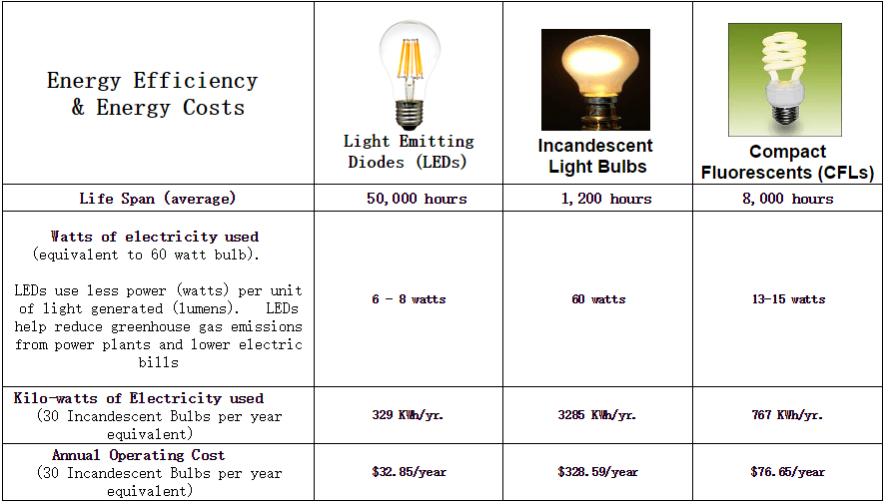4.1 Tables

Table 4.1 Energy Efficiency and Energy Costs of LEDs, Incandescent Light Bulbs and CFLs

Table 4.1 shows the Energy Efficiency and Energy Costs of LEDs, Incandescent Light Bulbs and CFLs. The differences of their life span, Watts of electricity used, Kilo-watts of electricity used and Annual Operating cost. Thus, lighting quality is much more than just providing an appropriate quantity of light. Other factors that are possible contributors to lighting quality include such as illuminance uniformity, luminance distributions, light color characteristics and glare (Veitch and Newsham 1998). LED stands for light emitting diode. Incandescent light bulb a light bulb whose light is produced by the glow of a wire heated by an electric current. CFL is an acronym that stands for compact fluorescent light. Life span average of LEDs is 50,000 hours, Incandescent Light Bulbs is 1,200 hours and CFLs is 8,000 hours. In the second row, shows the watts of electricity used. For, LEDs 6-8 watts, Incandescent light bulb is 60 watts and CFLs is 13-15watts. In the third row is the kilo-watts of electricity used. For the LEDs, 329 KWh/yr, Incandescent Light Bulb is 3285 KWh/yr and CFLs is 767 KWh/yr. In the fourth row, it shows the Annual Operating cost. For LEDs $32.85/year, incandescent light bulb is $3288.59/year and CFLs is $76.65/year. In conclusion to this, LED is 90% efficient, a compact fluorescent bulb is 85% efficient, and an incandescent bulb is only 10% efficient.

4.2 Figures

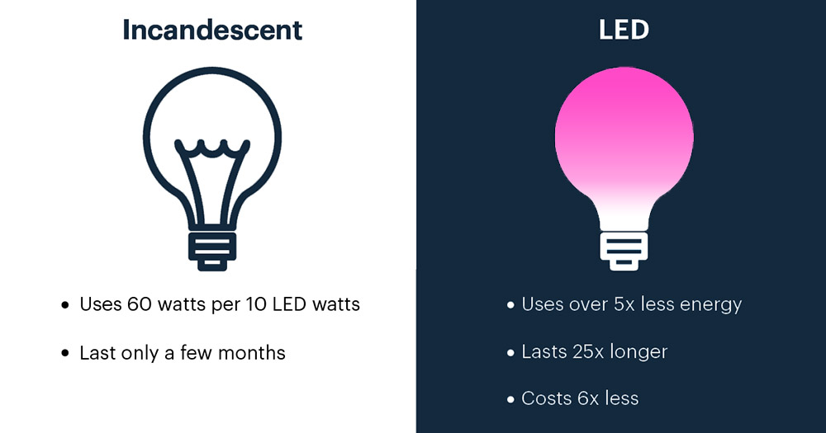

Table 4.2 Comparison of Incandescent to LED

**Table 4.2** shows the Comparison of Incandescent to LED. It states that Incandescent light bulb uses 60 watts per 10 LED watts while LED uses over 5 times less energy. In addition to this, Incandescent light bulb last only a few months while LED lasts 25 times longer.

4.3 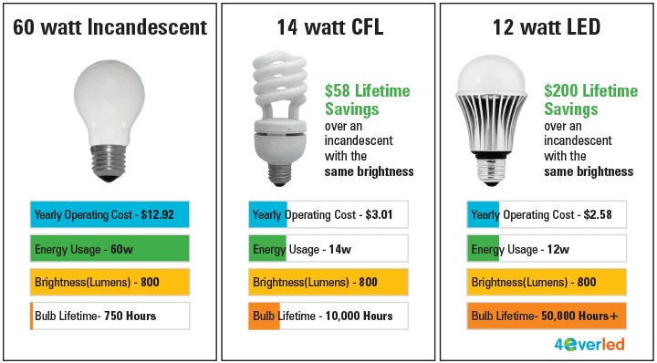

Table 4.3 Comparison of CFL to LED

**Table 4.3** shows the Comparison of CFL to LED. It states that CFL light bulb uses 14 watts with a bulb lifetime of 10,000 hours. It states that LED light bulb uses 12 watts with a bulb lifetime of 50,000 hours plus. In addition to this, CFL light bulb have a $58 lifetime savings while LED $200 lifetime savings.

ACKNOWLEDGMENTS

I wish to express my sincere appreciation to Professor Max Angelo P. Perin, Department of Engineering, Architecture and Industrial Design for expanding our prior knowledge in terms of being a researcher and pave the way for us to explore the world of sustainable energy engineering.

This task would have been a dream, if not for the support given by, my course Professor Max Angelo P. Perin, Department of Engineering, Architecture and Industrial Design. The constructive feedback, the knowledge imparted, and help given to successful completion of the project.

Last but not least, to my groupmates for bearing with me during preparation period and their constant understanding and moral support which gave me ample courage and confidence to accomplish my goals successfully.

REFERENCES

<bib id="bib1"><number>[1]</number>Cynthia J. Frey and Duncan G. LaBay (1983) ,"A Comparative Study of Energy Consumption and Conservation Across Family Life Cycle", in NA - Advances in Consumer Research Volume 10, eds. Richard P. Bagozzi and Alice M. Tybout, Ann Abor, MI : Association for Consumer Research, Pages: 641-646.</bib>

<bib id="bib2"><number>[2]</number>UASK Edirisinghe (2012). “ Study to evaluate the effectiveness of lighting system by using LED technology in Commercial buildings”. University of Vocational Technology Sri Lanka.</bib>

<bib id="bib3"><number>[3]</number>Kevin Tucker(2021). “The Many benefits of Step Lighting”. Washington DC, DC Metro, Columbia, Howard County, Montgomery County, Annapolis, Anne Arundel County.</bib>

<bib id="bib4"><number>[4]</number>Edirisinghe, Kamal & Abeyweera, Ruchira & Senanayake, N.. (2016). Evaluation of Effectiveness of LED Lighting in Buildings. SLEMA Jornal. 19. 10.4038/slemaj.v19i2.10.</bib>

<bib id="bib5"><number>[5]</number>Narendran, N. & Gu, Y. & Jayasinghe, L. & Freyssinier, Jean Paul & Zhu, Yiting. (2007). Long-term performance of white LEDs and systems. Proceeding of First International Conference on White LEDs and Solid State Lighting. 174-179.</bib>